**High Level Design for Flipkart Shopping Application**

1. Introduction:

Flipkart Shopping, which allows consumers to directly buy goods from a seller over the internet using a web browser or a mobile app. It enables search feature for the shoppers to find specific model or brands.

2. Requirement Summary:

* It offers users a convenient and secure platform to browse, select, and purchase products.
* With easy registration and login options, users can create profiles and manage shopping experiences effortlessly.
* We can explore a vast array of products through simple search and browsing features, with advanced filtering options.
* We can add items to cart and can place the order if required through a payment method.
* We can track the status of the order and timely updates on shipping and delivery.

This is a brief requirement summary for the flipkart shopping application.

3. High Level Design:

* A High-Level Design (HLD) is a technical document for a (generally) non-technical audience.
* It explains the architecture which is used to develop the system.
* It is a general system of design that describes the overall architecture of a system including modules, component, interactions and data flow without going into detail implementation specifics.

4. Functional and Non-Functional Requirements for Flipkart Shopping:

Functional Requirements:

1. User Registration and Authentication:

* Users should be able to register for an account with a valid email address and password.
* Users should be able to login securely using their registered credentials.

1. Product Searching and Filtering:

* Users should be able to browse through different categories of products.
* Users should be able to search for products using keywords and filters.

1. Cart Management:

* Users should be able to add items to shopping cart.
* So, they can view the content or update it.

1. Order and payment:

* Users can order the products by choosing a payment method.
* After, placing the order we can track the status of the product.

1. Customer Support:

* Users should have access to customer support channels for product assistance, inquiries, or technical issues.

Non-Functional Requirements:

1. Performance:

* The application should load quickly and respond to user interactions promptly.
* It should be able to handle large number of concurrent users without performance degradation.

1. Security:

* The data like personal information, payment details should be encrypted and stored securely.
* The application should be protected against common security threats.

1. Reliability:

* It should have user-friendly interface to navigate easily.
* It should provide clear feedback and guidance to users throughout the shopping process.

5. UML Activity diagram for Flipkart Shopping Application:

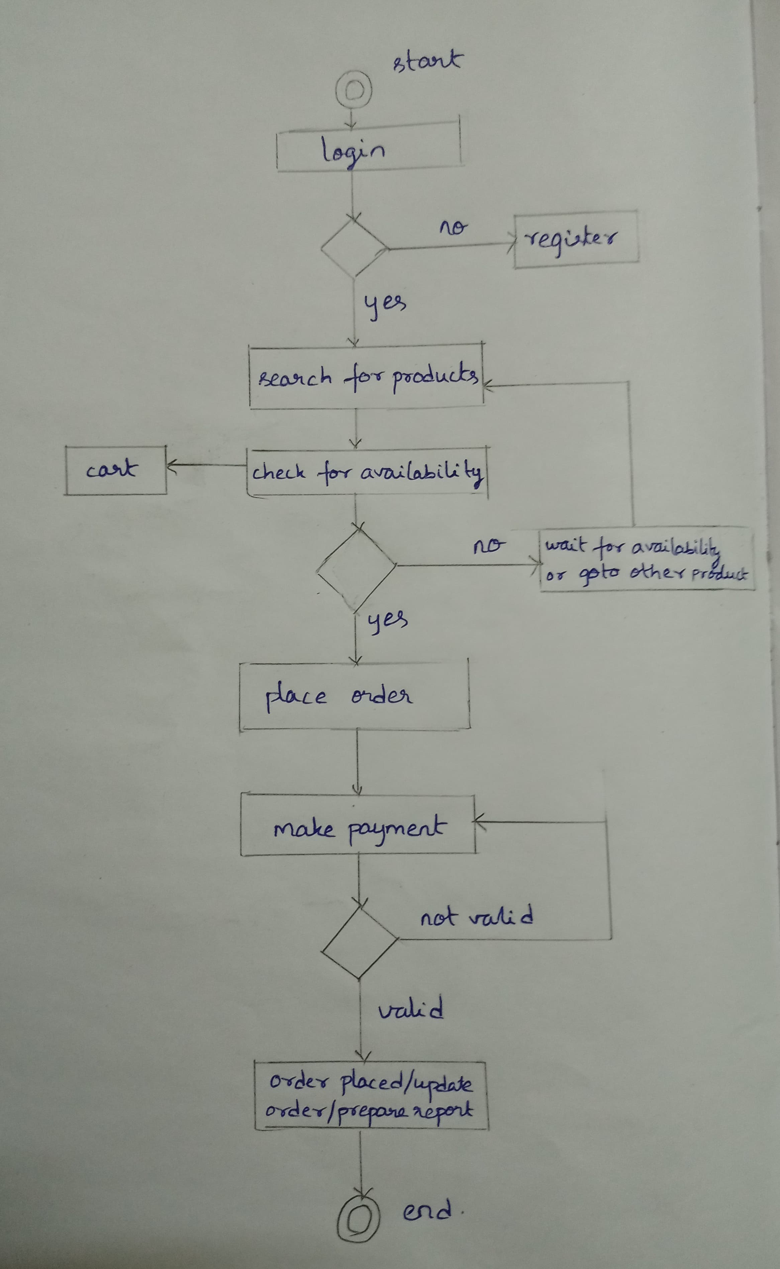

6. Features:

The features for flipkart shopping application are given below.

6.1 Login and Signup:

Signup:

* Users can sign up for an account by providing basic information such as name, email address and password.
* The registration form may include optional fields for additional details like phone number, address for two-factor authentication.
* After submitting the registration form, users receive a verification email to confirm the email address to activate account.
* Upon successful registration, users are redirected to login page.

Login:

* Registered users can login the application using their email address and password.
* The login process involves authentication to verify the user’s identity and grant access to their account.
* Upon successful login, users are redirected to their account dashboard or homepage, where they can start shopping.

Therefore, login page securely collects user credentials, which will be stored in user database. Upon successful validation, users can access the application otherwise it raises an authentication failure.

6.2 Product Search and Filtering:

Search Functionality:

* Users can enter keywords or phrases related to the product they’re looking for into a search bar.
* The application searches its database for products matching the search query.
* Search results are displayed in the user, typically sorted by relevance or popularity.

Filtering:

* To refine search results, users can apply various filter based on specific criteria.
* It may include filtering for options such as category, price range, brand, colour and other attributes etc.

Therefore, search and filtering page enables users to easily search for products by using filtering options.

6.3 Cart Management:

* Users can browse through product listings and select items they want to purchase.
* Each selected item can be added to the shopping cart with a single click or tap.
* The item is then stored temporarily in the cart until the user proceeds to checkout or remove it.
* In cart there are options to view the entire contents, update or remove it.

Therefore, cart management feature enables the users to select and manage items they intend to purchase.

6.4 Order and Payment:

* After adding products to the cart, if they intend to purchase they can click the option checkout to initiate the order process.
* It checks whether the product is available or not. After confirming the order details it collects necessary information such as shipping address, contact details, and payment method during checkout.
* In payment page, we can choose the preferred payment methods and order can be placed.
* Upon receiving payment authorization, it initiates the order fulfilment process.
* Finally, we can track the order status.

Therefore, order and payment are fundamental components of the shopping platform.

6.5: Reviews:

* Users can write reviews for the product factors such as quality, performance and value for money.
* Reviews often include pros and cons, along with recommendations and tips so that the platform can take the decisions to improve the quality of the product.
* It helps the user’s transparency and satisfaction to the consumers.

Therefore, product reviews in a shopping application provide valuable insights for potential buyers by allowing previous purchasers to share their experiences and opinions.